



**A CRM APPLICATION TO MANAGE THE SERVICES**

**OFFERED BY AN INSTITUTION**

1. **PROJECT OVERVIEW**

This project is focused on the development of a Customer Relationship Management (CRM) Application for Institutions. The main goal is to centralize and simplify the administration of the services that institutions provide, guaranteeing smooth communication, effective operations, and increased user satisfaction. This CRM program offers a unified platform to handle interactions, service requests, and customer feedback. It was created to address issues including disjointed service monitoring, a lack of real-time analytics, and ineffective communication. By utilizing contemporary technology, such as cloud-based platforms, automated workflows, and real-time analytics, the objective is to provide a comprehensive solution.

By ensuring data accuracy, improving user experience, and increasing operational efficiency, this initiative will enable institutions to provide individualized services and make data-driven decisions. By improving interactions with students, employees, and external stakeholders and making the most use of available resources, this CRM solution helps the institution achieve its long-term objectives.

1. **OBJECTIVES**

***Business Goals:***

Enhance Service Efficiency: Reduce response times and operational bottlenecks by streamlining the institution's service delivery process.

Increase User Involvement: Using an established and easily accessible platform, it improved the communication with students, employees, and other stakeholders.

Data-Driven Decisions: Use analytics to produce actionable insights that can help the organization optimize its resource allocation and service initiatives.

Increase Openness: To foster accountability and trust, make it easier to track service requests, progress, and feedback in real time.

Scalable Resolution: Create a CRM program that can grow with the organization as its needs do.

***Specific Outcomes:***

A single dashboard for monitoring and controlling all institutional services and client communications is known as centralized service management.

Automated Workflows: To reduce manual interventions, automated notifications, task assignments, and follow-up reminders are implemented.

Better User Interface: An easy-to-use and intuitive design that makes it simple for administrators, employees, and end users to use.

Analytics and Reporting: Comprehensive reports on operational effectiveness, user satisfaction, and service indicators to support performance assessment.

Secure Data Storage: Strict protocols to guarantee the privacy and security of private user and institutional information.

1. **SALESFORCE KEY FEATURES AND CONCEPTS UTILIZED**

***Essential Features:***

Custom Fields and Objects: Created and modified assets (such as students, courses, consultants, and appointments) to meet the CRM requirements of the organization. And defined particular fields to precisely store and arrange necessary data.

Data modelling and relationships: For improved data interconnection, Lookup Relationships were created to connect objects such as Student and Course.

Workflow Rules and Process Builder: Automated recurring tasks, such as notifications and reminders.

Approval Procedures: Made ensuring that decisions regarding service-related requests were made quickly.

Dashboards and Reports: Created thorough reports to track customer happiness, service performance, and other important indicators and developed dashboards for tracking progress and visualizing institutional data in real time.

***Concepts Utilized:***

Apex and Visualforce: Customized functionality through Apex triggers and Visualforce pages for unique project requirements.

AppExchange Integration: Integrated third-party tools and plugins from Salesforce AppExchange to extend functionality.

Role Hierarchies and Sharing Rules: Implemented security by defining role hierarchies and sharing rules for data accessibility.

Communities: Created Salesforce Communities for external stakeholders to access relevant data and interact with the institution.

Mobile App Access: Enabled Salesforce Mobile App features, ensuring on-the-go access for users.

1. **DETAILED STEPS TO SOLUTION DESIGN**

**CUSTOM OBJECTS AND FIELDS:**

Created customized objects (such as Student, Course, Consultant, Appointment, Registration) tailored to the institution’s CRM needs. Defined a specific fields to store and organize essential data.

**Object-Course**

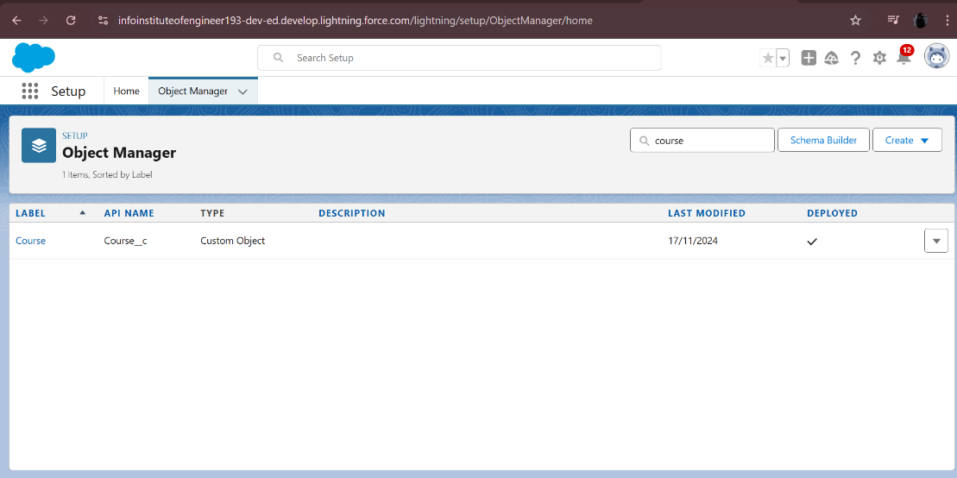

**Object-Appointment**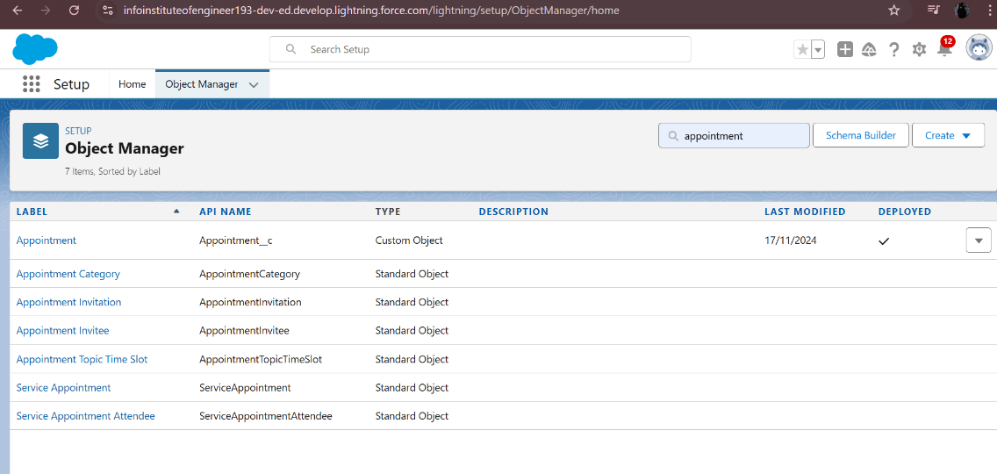

**Object-Consultant**

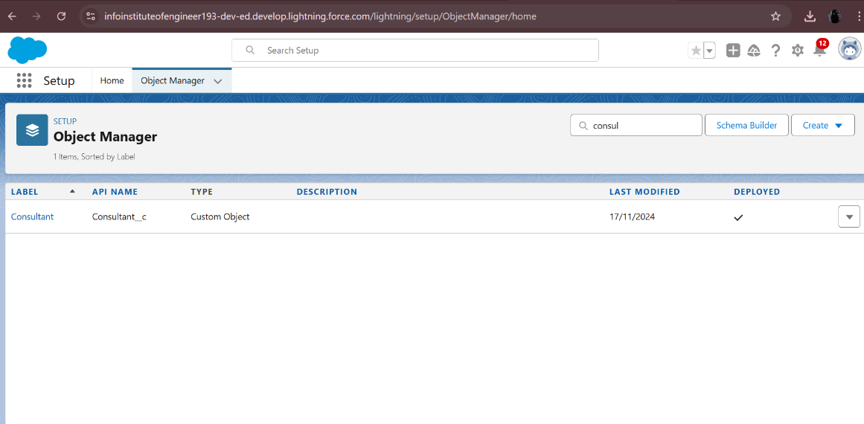

**Object-Student**

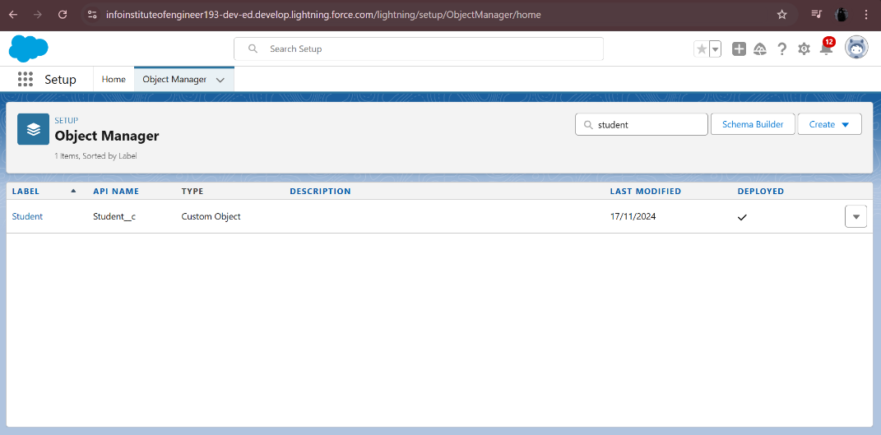

**Object-Registration**

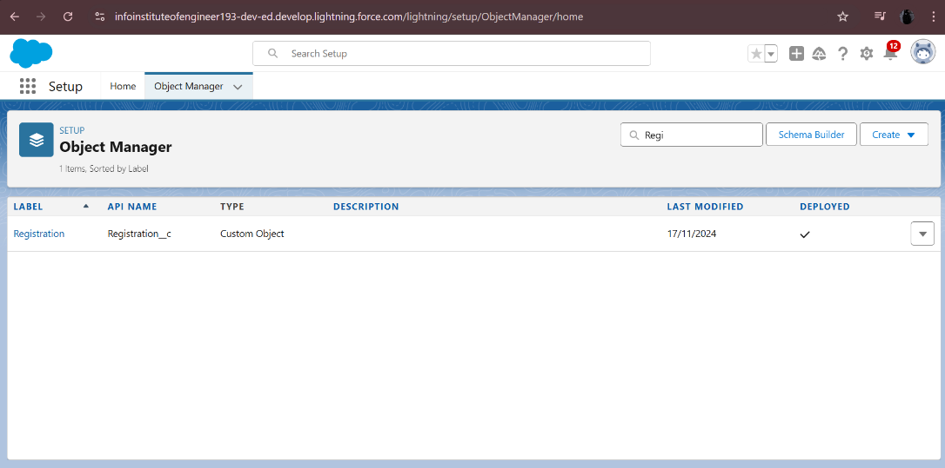

**RELATIONSHIPS AND DATA MODELING:**

Established Lookup Relationships to link objects like Student and Course for better data interconnectivity. Maintained hierarchical and structured data to represent real-world relationships.

**Created a lookup between appointment and student, appointment and consultant:**

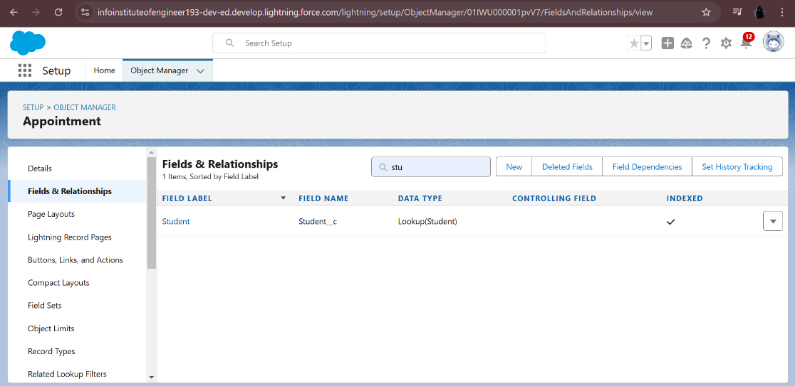

**Created a lookup between student and case:**

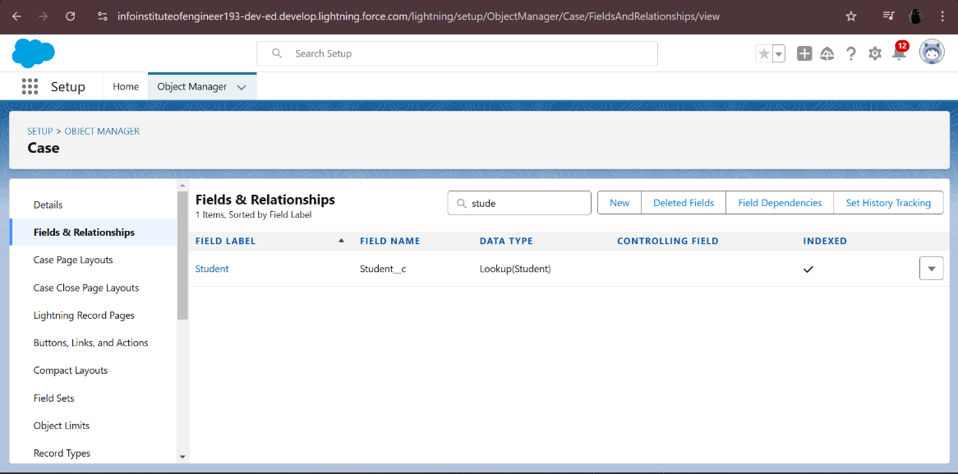

**Automation Tools:**

**Approval Processes: Ensured streamlined decision-making for service-related requests.**

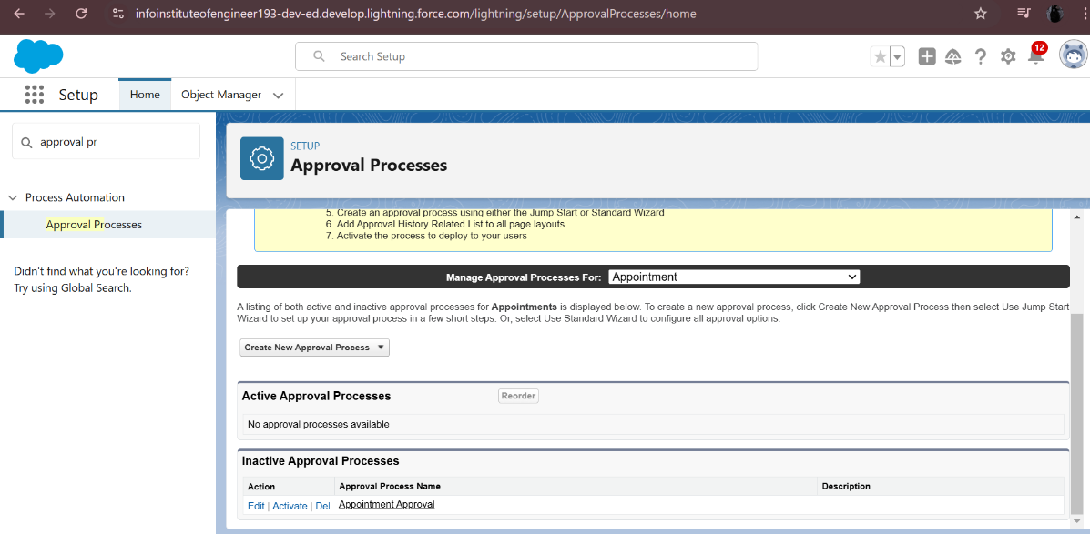

**BUSINESS LOGIC:**

Flow Builder: A flow leads users through the entire student registration process, which includes choosing a course, filling out information, and verifying enrollment. automated sophisticated logic and developed guided workflows.

* Screen Flows: Give consumers access to dynamic data entry forms.
* Record-Triggered Flows: When something changes, linked records are automatically updated.

**EduConsultantPro Existing Student Flow**

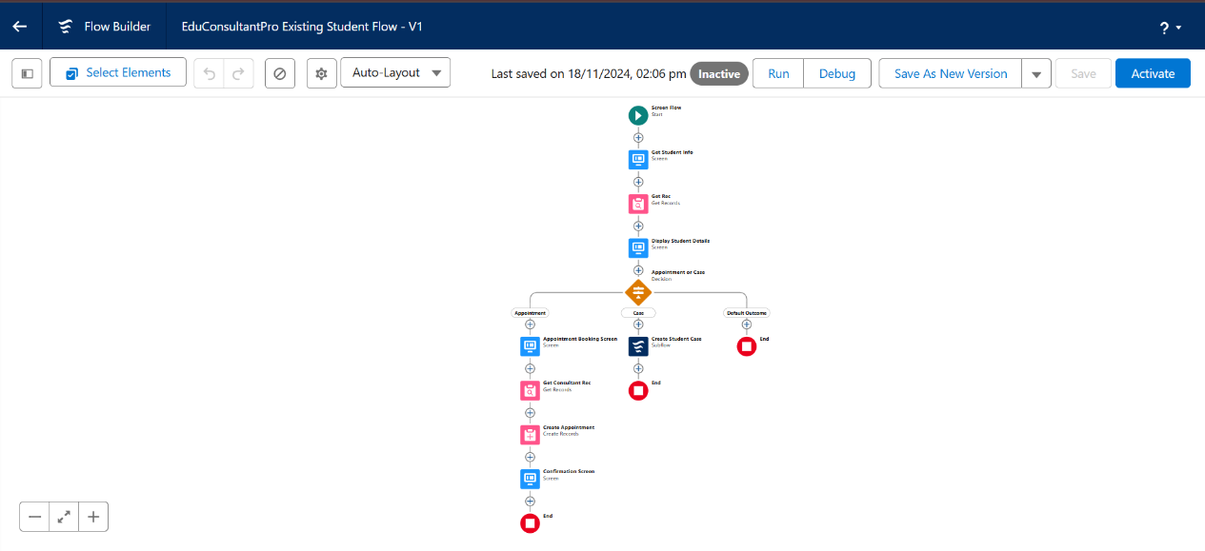

**EduConsultantPro Student Flow**

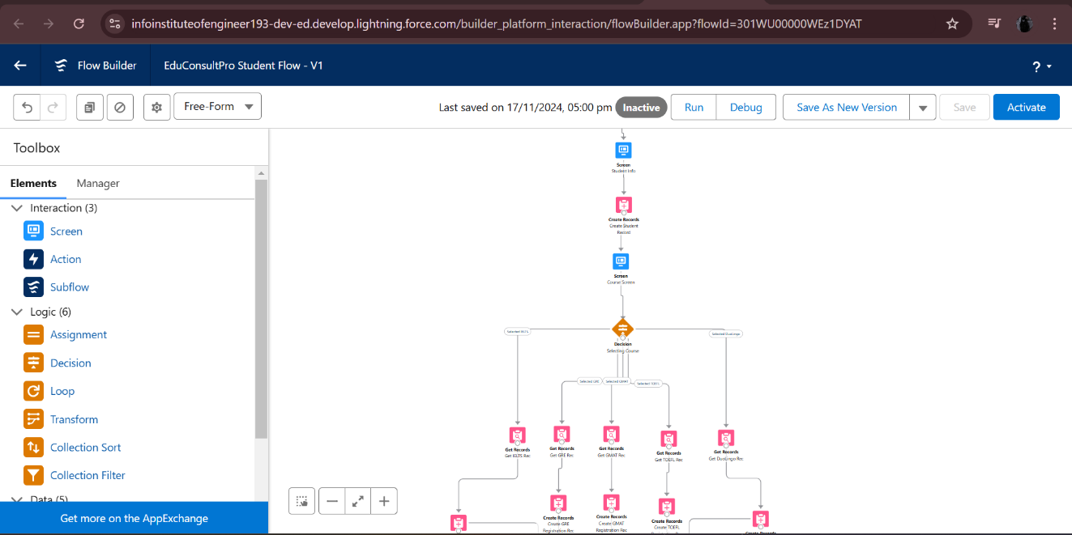

**EduConsultantPro Approval Flow**

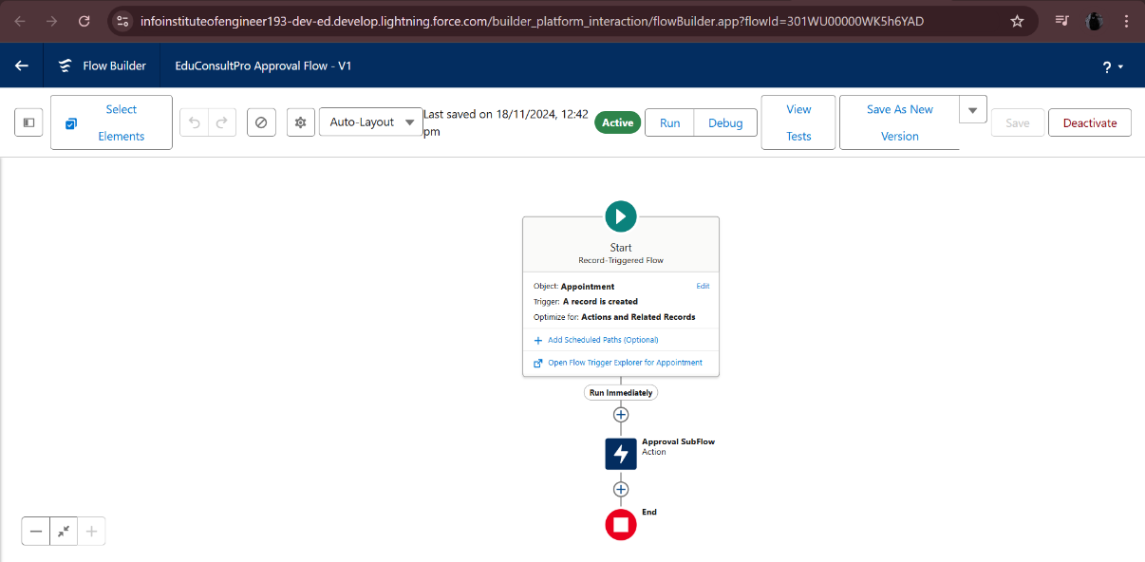

**EduConsultantPro Flow**

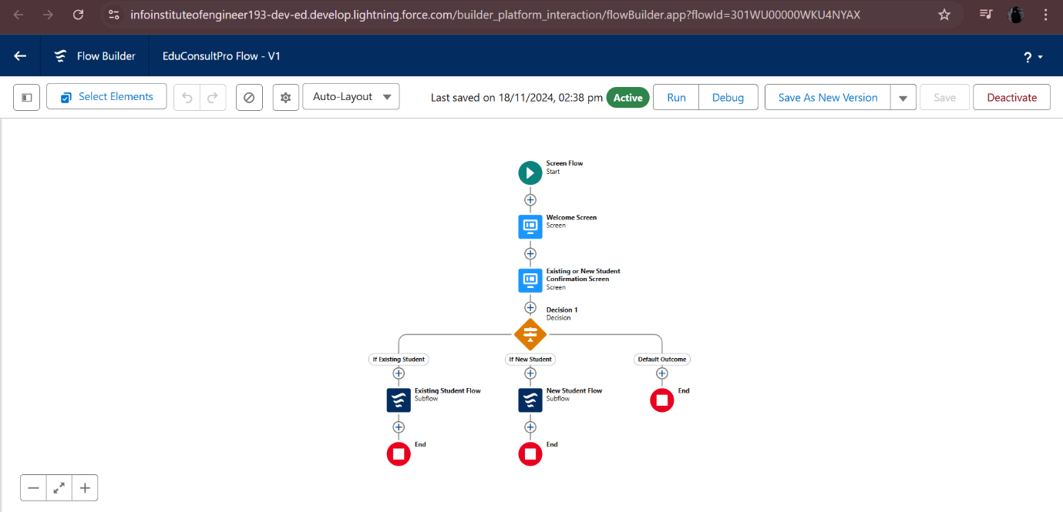

1. **TESTING AND VALIDATION**

To make sure the Salesforce CRM application satisfies user needs, works as intended, and is error-free, testing is essential. There are several testing phases in this approach:

Unit testing's main goal is to confirm that backend elements like Apex Classes and Triggers work as intended.

**Apex Classes**: To validate specific Apex class methods, we have to create test classes in Salesforce. Verifying the accuracy of the logic used for computations, data processing, or business rules. Discussing the test instances that are both positive and negative.

**Triggers:** Test is done in every situation in which triggers (such as insert, update, and delete operations) are triggered. Verifying that triggers handle bulk data correctly and operate as intended.

**Tools for Testing:** Make use of third-party tools such as Visual Studio Code with Salesforce Extensions or the integrated Developer Console in Salesforce. The requirement for code coverage is at least 75% of the code should be covered.

**USER INTERFACE(UI) TESTING**

The goal of user interface (UI) testing is to make sure that every component of the Salesforce interface works properly and is easy to use.

Testing the Layout of Pages: Checking all required fields, relevant lists, and buttons are displayed on record pages.Verifying responsiveness across a variety of devices, including desktop, tablet, and mobile.

Testing Workflow: Verifying the automated procedures that are started by user interface actions (such as button clicks or form submissions) function as intended.

Testing of Lightning Components: Verifying the data binding, interactivity, and accurate rendering of custom components.

Validation of Forms: Verify that necessary fields correctly display error messages and enforce appropriate input validation.

1. **KEY SCENARIOS ADDRESSED BY SALESFORCE IN THE IMPLEMENTATION PROJECT**

Reporting and Analytics Scenario: The organization needs to know about service requests, consultant performance, and enrolment patterns. Custom dashboards and reports with real-time information are the answer.

Multi-Device Access Scenario: Administrators, employees, and students must have access to the system via mobile devices, tablets, and PCs.

Integration with Current Frameworks: The organization needs to seamlessly integrate its current email platforms and student information systems (SIS). Using API connectors to synchronize data between external systems and Salesforce. Workflows that are automated to initiate operations (such as sending emails or amending SIS entries).

Role management and user access: Access to data and functionalities must be customized for various user roles, such as administrators, consultants, and students. Using of sharing rules and role hierarchies to guarantee safe, role-based data access. Permission sets allow for fine-grained, adaptable functionality control.

1. **CONCLUSION**

**EDUCONSULTANTPRO**

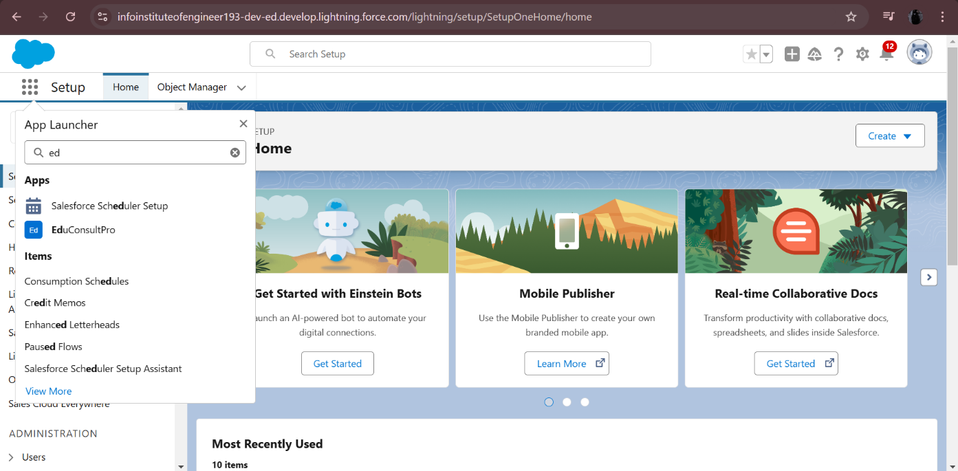

**EDUCONSULTANTPRO STUDENT FLOW**

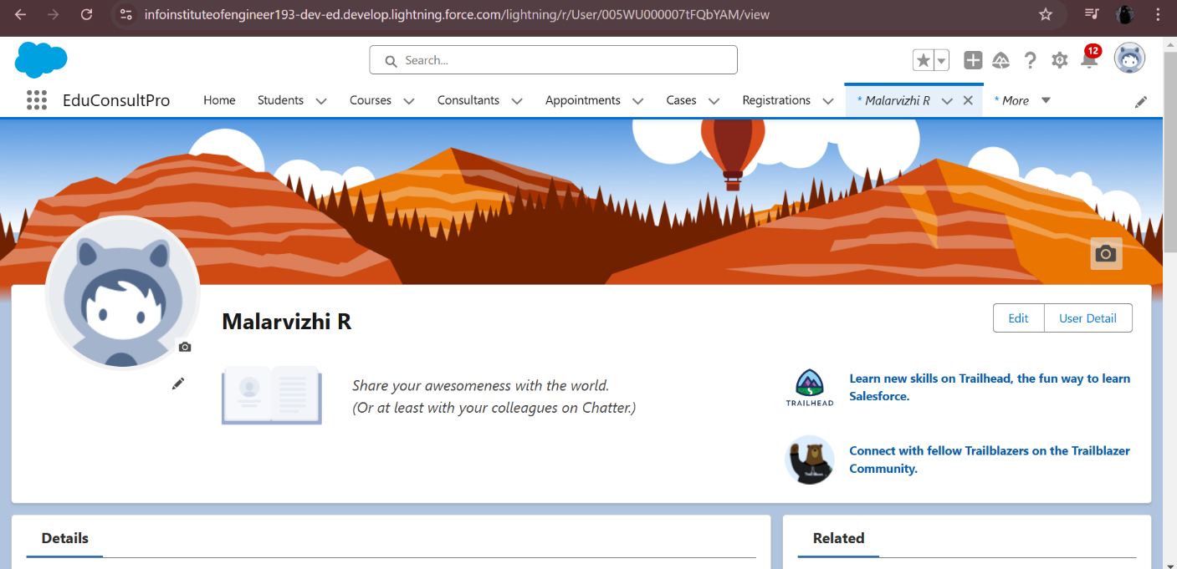

By automating crucial procedures including consultant assignments, course administration, student enrolment, and appointment scheduling, the Salesforce CRM platform has completely transformed the institution's service management. These developments have ensured that resources are used efficiently by streamlining processes, lowering manual labour, and increasing operational efficiency. The overall user experience has been improved by the system's responsive and easy-to-use interface, which offers administrators, employees, and students alike seamless device accessibility. Secure data sharing and role-based access controls further guarantee the protection of sensitive data while permitting customized access to critical features.

Along with enhancing operations, the Salesforce platform has given the organization access to real-time analytics and reporting, which has produced actionable insights for improved decision-making. It is now simpler to monitor trends, assess performance, and foresee future requirements thanks to customized dashboards and reports. By implementing this updated method of service management, the organization is not only tackling present issues but also setting itself up for future expansion and flexibility, maintaining its lead in a constantly changing educational environment.